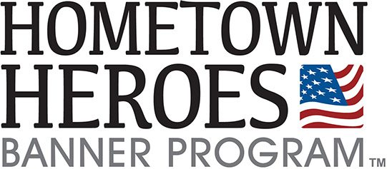
Edgerton Honoree Profile
Please fill this form out completely

Rank: ___________________________________________________________
First Name: ______________________________________________________
Last Name: _______________________________________________________
Branch of Service: _________________________________________________
Era: ____________________________________________________________
Era:
- Global War on Terror (Sept 22, 2001 - Present)
- Persian Gulf War (Aug 22, 1990 - Aug 31, 1991)
- Cold War (Sept 2, 1945 - Dec 26, 1991)
- Vietnam Conflict (Feb 28, 1962 - Nov 7, 1975)
- Korean War (June 27, 1950 - Jan 31, 1955)
- WWII (Dec 7, 1941 - Dec 31, 1946)
- WWI (Apr 6, 1917 - Nov 11, 1918)
- Spanish American War (Apr 1898 - Aug 1898)
- Civil War (1861 - 1865)
Sponsor: _________________________________________________________
Phone: __________________________________________________________
Status (KIA / POW / MIA): ___________________________________________
Medals (Purple Heart / Silver Star / Bronze Star): _________________________
We will insist on a picture of those medals as needed. If you require a different medal you will need to supply a high-resolution photo.
The cost of each banner and bracket is $ 175 each.
If you are interested in sponsoring or need help, please let us know. Placement will be random throughout the town’s main highways. Honoree’s must be an Edgerton High School graduate OR a former/current resident of Edgerton Local School District.

Make checks payable to Edgerton Chamber of Commerce. First round applications due 2/15/2021.

Send form, picture and checks to: Edgerton Chamber of Commerce
Tomara Rhoden, Program Organizer
PO Box 682
Edgerton, Ohio 43517

Disclaimer: This is a private initiative with the support of Edgerton Chamber of Commerce. I nor The Village nor Chamber are responsible of any placement cost.

