Edgerton is Honoring its Service Members!

Village of Edgerton is launching a Hometown Heroes Banner Program as a living tribute for our community to honor past and present members of the Armed Forces members. Each banner will be two sided and placed on electric poles around town from May until November.

If you would like to volunteer, sponsor, or know of a loved one that you would like to honor,
please fill out a Honoree Profile and send a high quality picture to be placed on banner. All photos will be returned to you. Anyone can sponsor a banner but the Honoree must be an Edgerton High School graduate OR a current/former resident of Edgerton Local School District.

Each banner requires the Hometown Hero application process be completed prior to the banner order being placed. No banner will be printed until full payment is received.

Send application and payment to
Edgerton Chamber of Commerce
Tomara Rhoden, Program Organizer
PO Box 682
Edgerton, Ohio 43517
Phone 419-630-5688
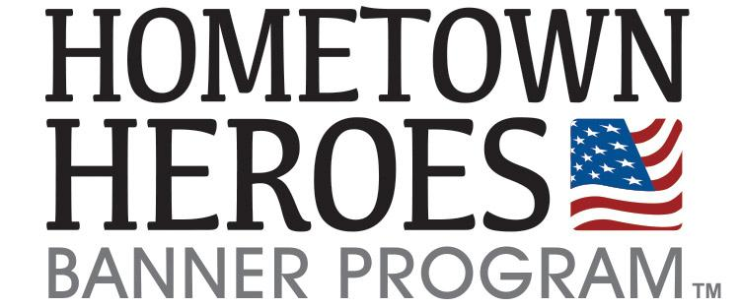
Email:Trhoden74@gmail.com

